Week7

Indexes and stuff

1. Werkly load to week7 schema
2. Big Table
   1. Create a new table from dbpostman.a4orderhistory (should be 700000+ rows) – call it bigdata using create and select

* 1. Go ahead and make a primary key on column id
  2. ~~We need to create a new unique column (I would use invoiceid and sequence) – call it indexcolumn – we can create a new column of data from existing columns with a simple update statement using the CONCAT function to create a longer unique string~~
  3. We need to do some baselines

Find the last item In the big table

Now query for all rows in descending order based the indexcolumn

Record its id the indexcolumn

Now query for that row via

The primary key

The indexcolumn (without the index)

Record the time to fetch and return data (workbench at the far right)

* 1. Now create an index on the indexcolumn
  2. Now perform the baseline queries again and note the difference from the first time
  3. Perform the reorder query (order by) on the indexcolumn for all rows in descending order

We should see improvements in response times

1. The Pile of data
   1. Create a new table pileofdata with a single column ‘bigcolumn” of 2000 characters
   2. We need to populate this column from dbpostman.
2. dbpostman.

Customers.name

* + - 1. Customers.customerid
      2. Addresses.street
      3. Addresses.city
      4. Addresses.state
      5. Addresses.country
      6. Addresses.zip

dbpostman.

We should put the pipe’|’ in in between them

We can smash them together by using the CONCAT function

insert into week7.pileofdata (bigcolumn) select concat(Customers.name,concat('|',concat(Customers.customerid,concat('|',concat(Addresses.street,concat('|',concat(Addresses.city,concat('|',concat(Addresses.state,concat('|',concat(Addresses.country,concat('|',concat(Addresses.zip,concat('|',concat('|',concat(Addresses.state,concat('|',concat(Addresses.country,concat('|',concat(Addresses.zip,'|')))))))))))))))))))) from Customers, Addresses

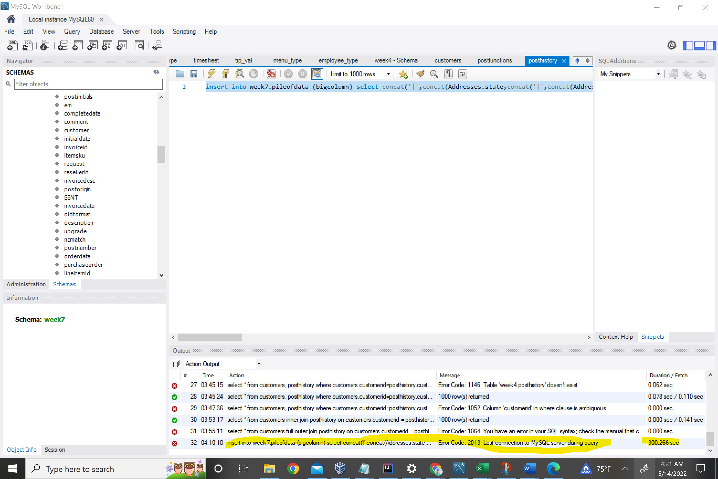

Query didn’t complete so I’m using the shell

Querry didn’t work